Flexi totals Unbalances

We have received a request into the EMS box and the EMS number is CBA9695336 they provide below screen shot and asking for the reason of unbalance.

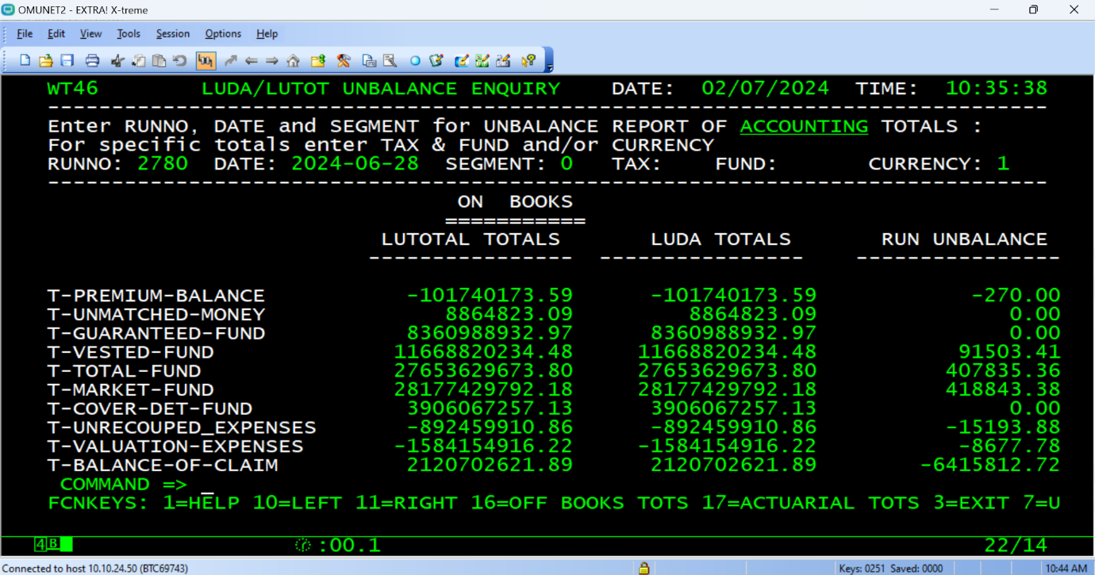
On a daily / weekly/ monthly / adhoc basis, there are XLU and XLC jobs that create files that are read by XWT jobs. The data in these files is accumulated in O* tables and can be viewed via the WTOT dialogues.

Once a week job ABCD#200 extracts the LUDA totals and those are also loaded to O*. If there is a mismatch between LUDA and LUTO the only we will see mismatch records like above screen.
Below are the steps which we have to follow to see the above screen on Mainframe.
First login into Mainframe and select HRNP from the main menu option, below is the screen shot for the same.
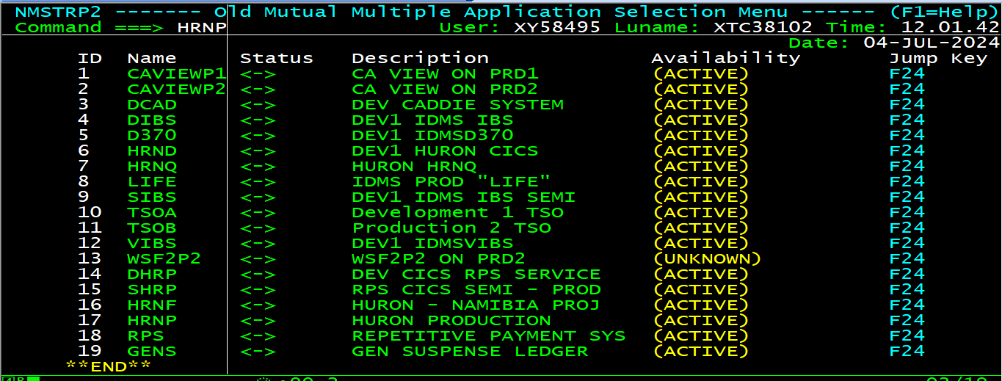
Once you will press ENTER you will see below screen and now go to the option “ZZMN ZZ MENU SYSTEM” with tab key and press ENTER, below is the screen shot for the same.
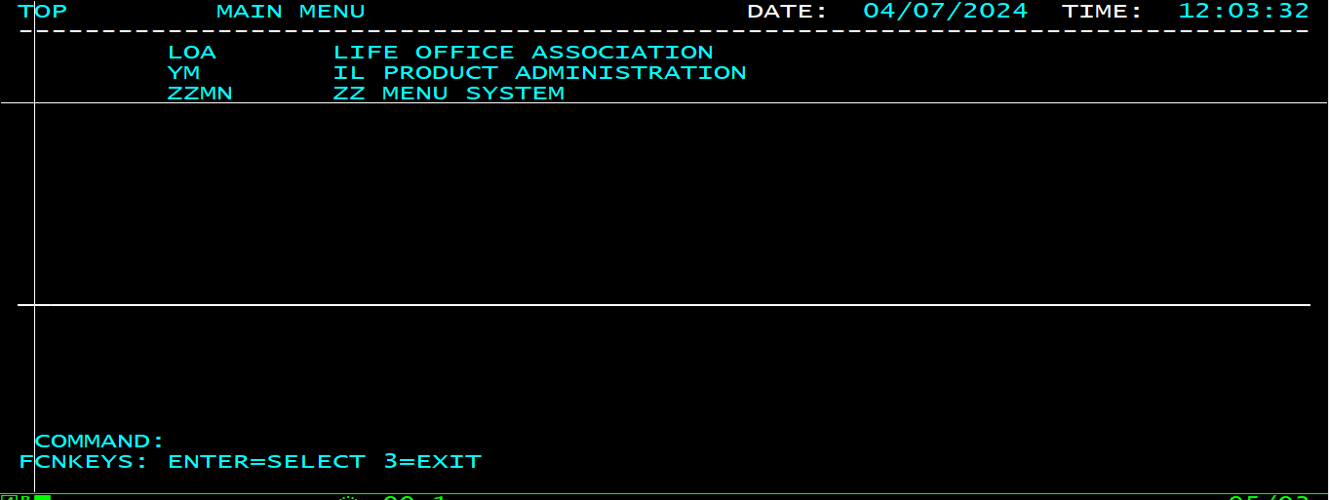
Once you will press ENTER now you will see MENU items and now on the command line type WTOT and press ENTER, below is the scree shot for the same.
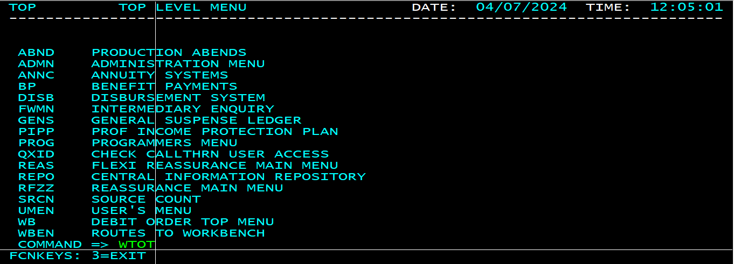
Now from this screen we have to select “UNBL UNBALANCE MENU” option and press ENTER, below is the screen shot for the same.
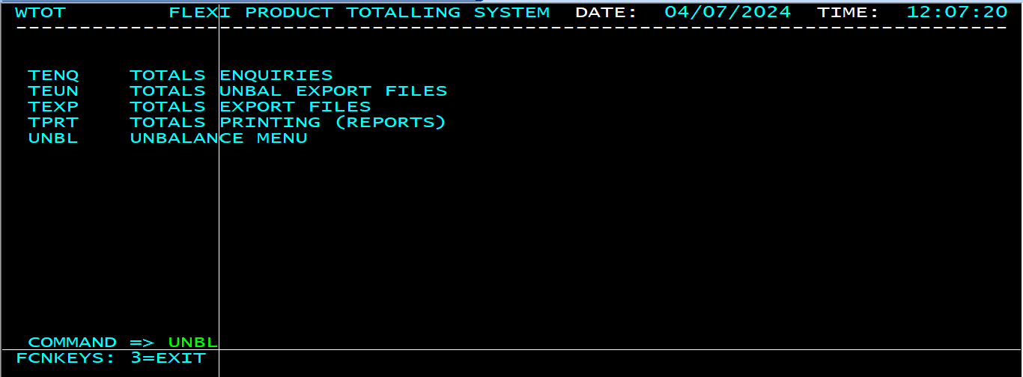
Now from this screen we have to select “VALID CYCLE/DATE COMBINATIONS” option and press ENTER, below is the screen shot for the same.
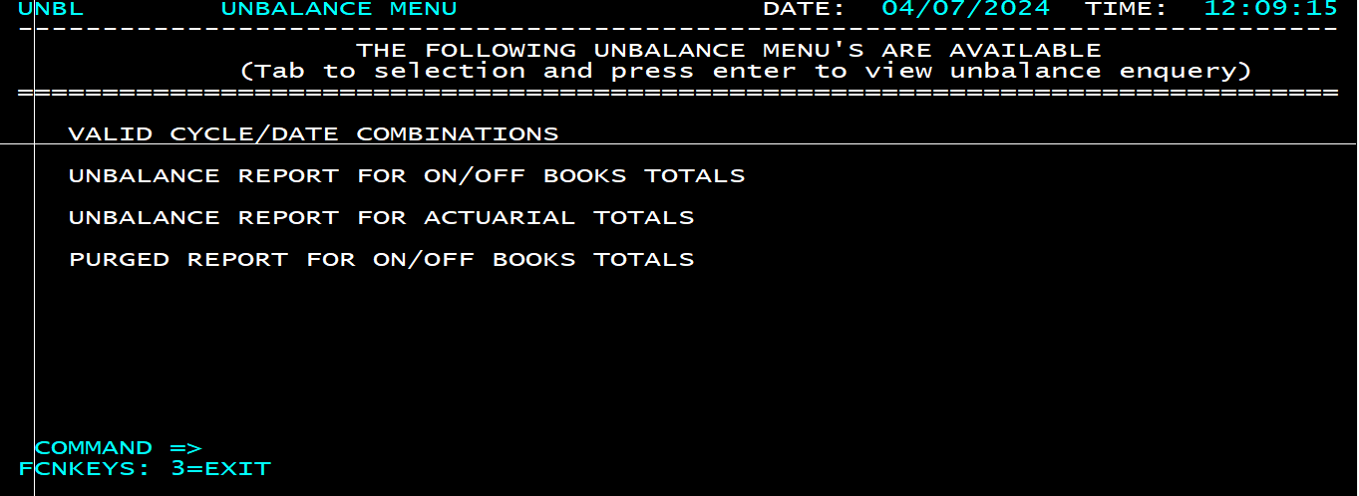
Once you will press ENTER we will see below screen.
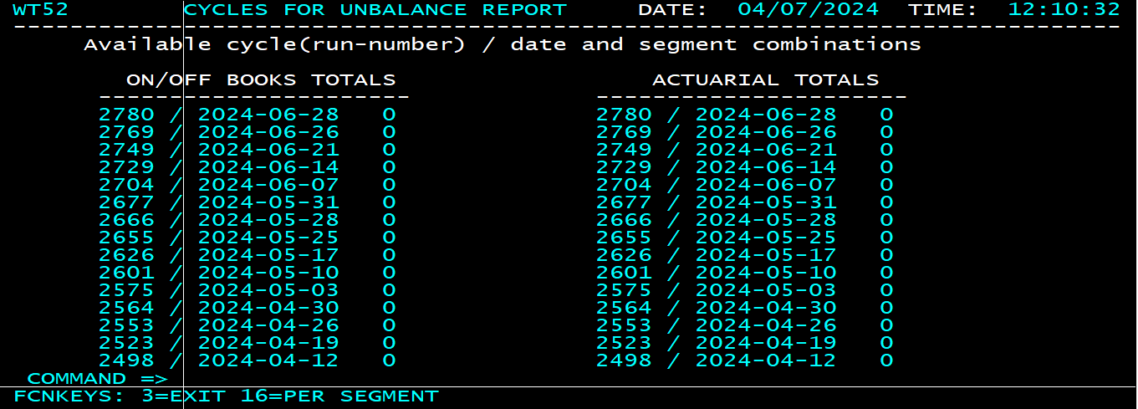
From this screen we got the cycle number and the dates, we need these to find out in which week we have unbalance.
To find out unbalanced, we have to follow below steps.
Now select option “UNBALANCE REPORT FOR ON/OFF BOOKS TOTALS” and press ENTER, below is the screen shot for the same.
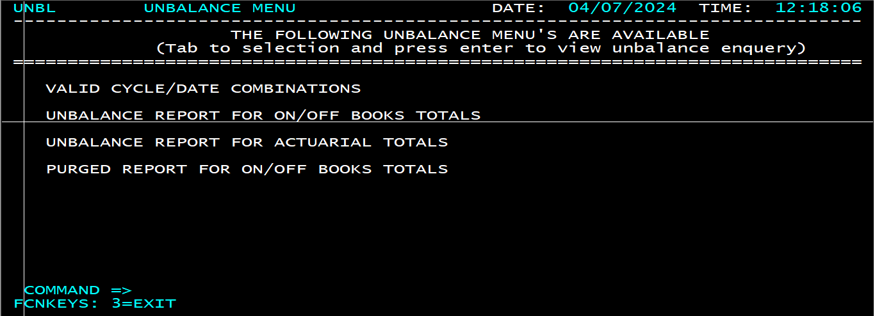
Once you will press ENTER we will see below screen.
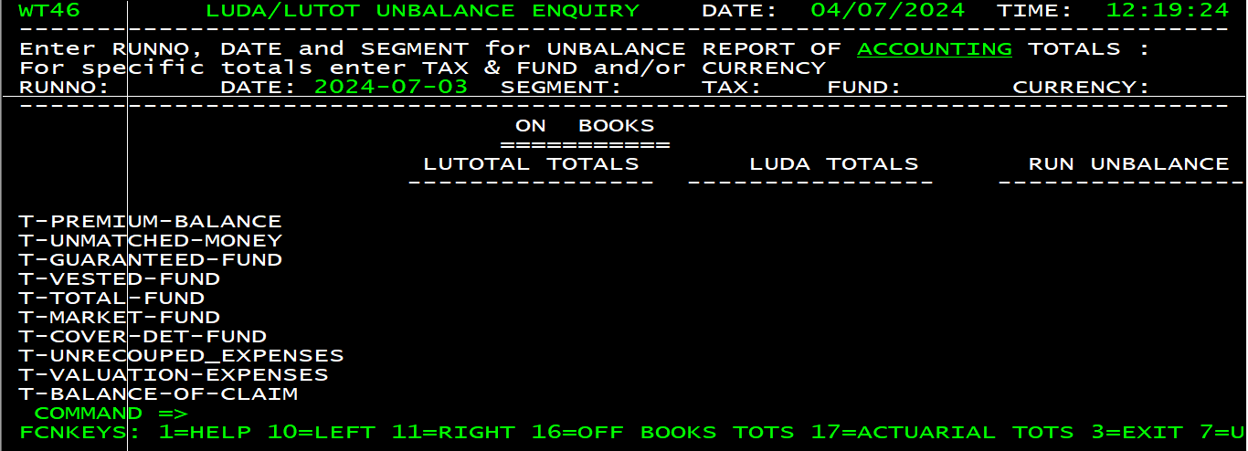
Now on this screen we have to value of the below variables.
RUNNO Now start providing values from the start of the month, according to the below table.
DATE Now start providing values from the start of the month, according to the below table.
RUN NUMBER/DATE
2780 / 2024-06-28 0
2769 / 2024-06-26 0
2749 / 2024-06-21 0
2729 / 2024-06-14 0
2704 / 2024-06-07 0
2677 / 2024-05-31 0
SEGMENT We will provide 0, which means for all segments.
TAX Leave it blank.
FUND Leave it blank.
CURRENCY We are providing 1, because while asking requestor has mention there is unbalance into RSA.
After providing all the values once we will press ENTER, we will see below screen.
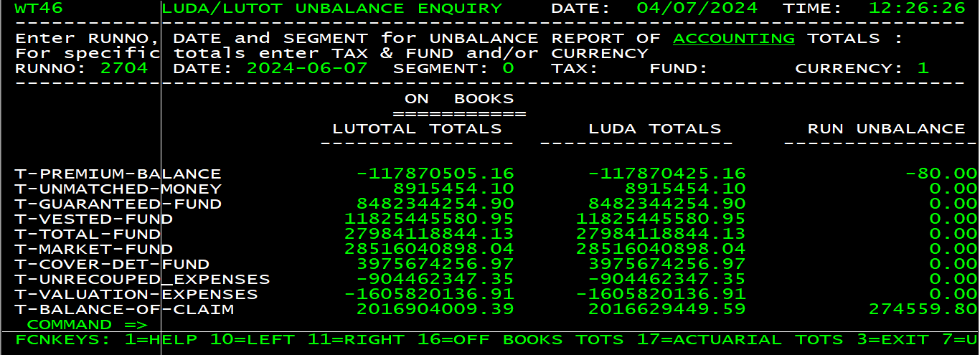
Here all the values into column “RUN UNBALANCE” is Zero except T-PREMIUM-BALANCE & T-BALANCE-OF-CLAIM. It means that there is no unbalance in this week.
Now we will provide next RUNNO & DATE and press ENTER, below is the screen shot for the same.
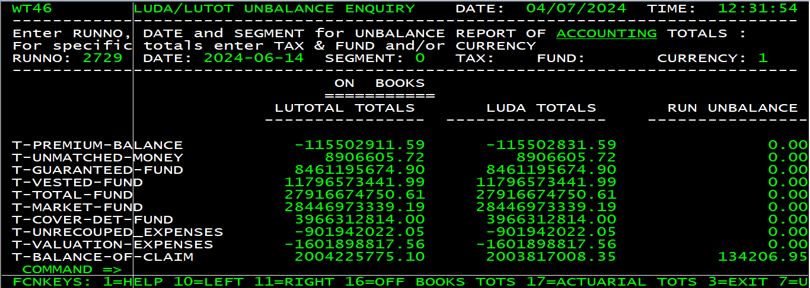
Here all the values into column “RUN UNBALANCE” is Zero except T-BALANCE-OF-CLAIM. It means that there is no unbalance in this week.
Now we will provide next RUNNO & DATE and press ENTER, below is the screen shot for the same.
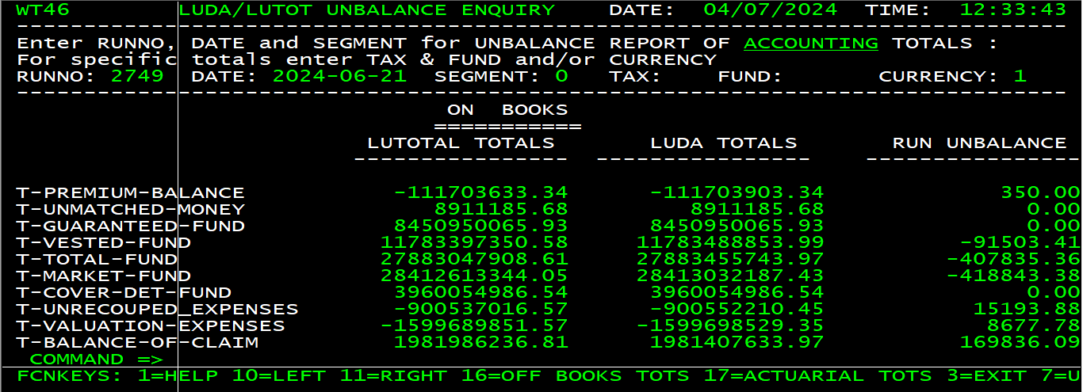
Here all the values into column “RUN UNBALANCE” is greater than Zero it means that unbalance has happened into this week and date can be 17 to 21 June. We have checked these amounts, and they are matching with the amount which we have received from requestor.
Now we have to narrow down this unbalance for that first, now we will first find out in which segment it has happened. Till ow we have provided 0 value into segment field, it means all the segment.
Now we will provide value of the variable SEGMENT starting from 1 to 7. Below is the screen shot after passing 1 value.
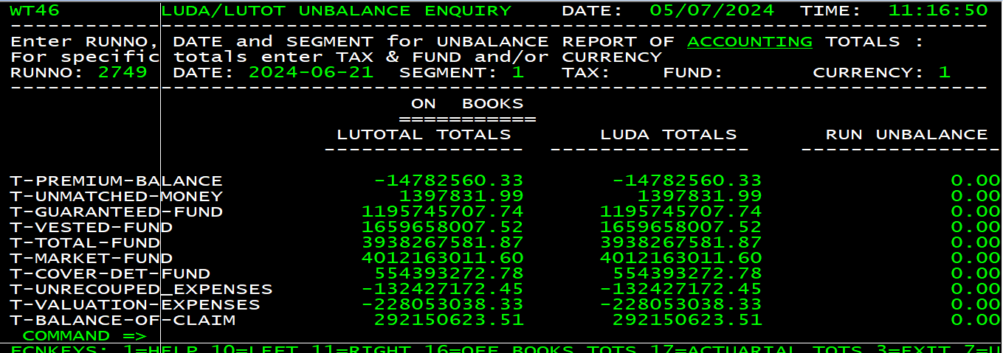
If we see “RUN UNBALANCE” column is Zero it means that there is no unbalance into segment 1.
Carry on and now we have provided value 3, we got the same amounts into “RUN UNBALANCE” column which we have received from requestor. Below is the screen shot for the same.
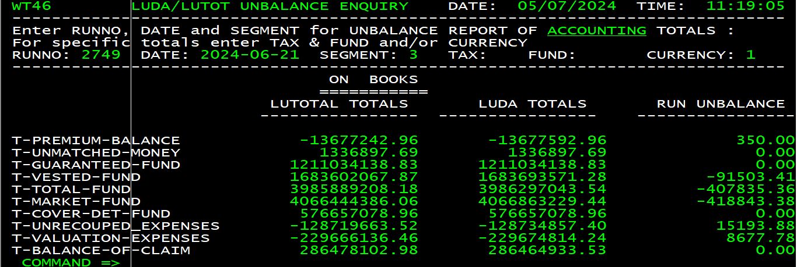
It means that this unbalance has happened into segment 3.
Now we have to narrow it down more on a TAX & FUND level.
TAX T & R
FUND 07 to 24
So now we will try all the FUND combination with TAX value T, starting from 07. Below is the screen shot of the few TAX & FUND combination.
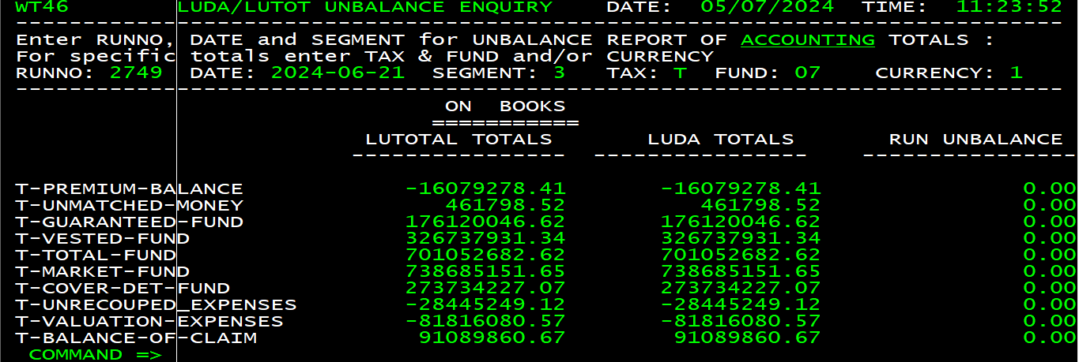
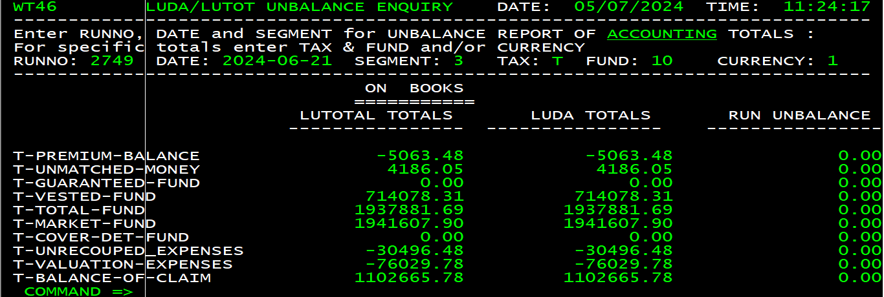
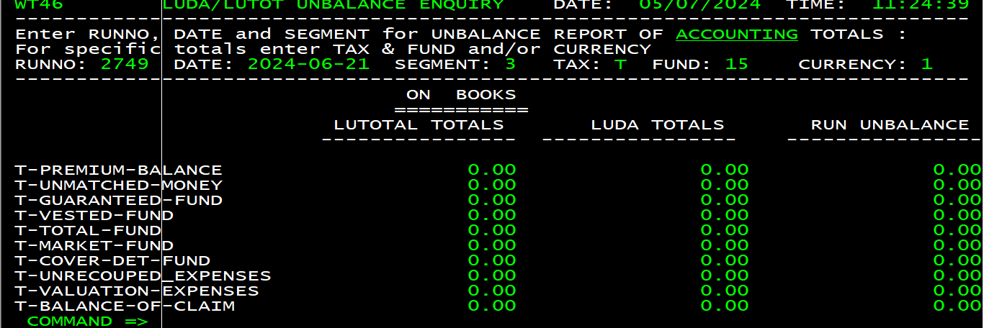
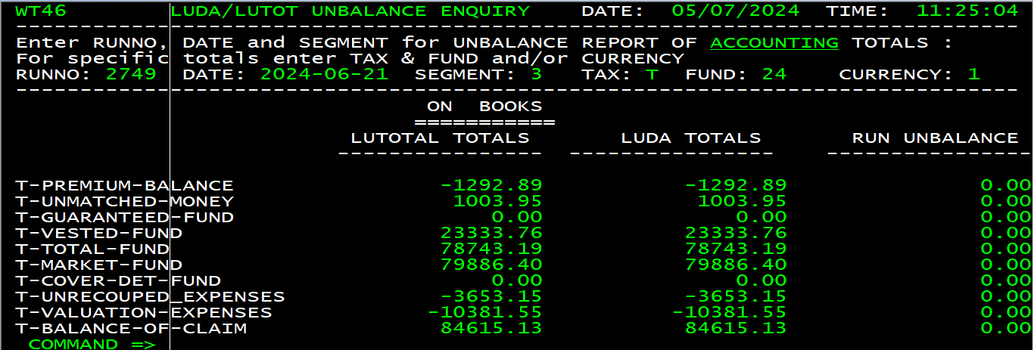
We haven’t found any unbalance with TAX = R and for all the FUND starting from 07 to 24.
Now we will try for other TAX = R and all the FUND starting from 07 to 24, below is the screen shot for the first combination.
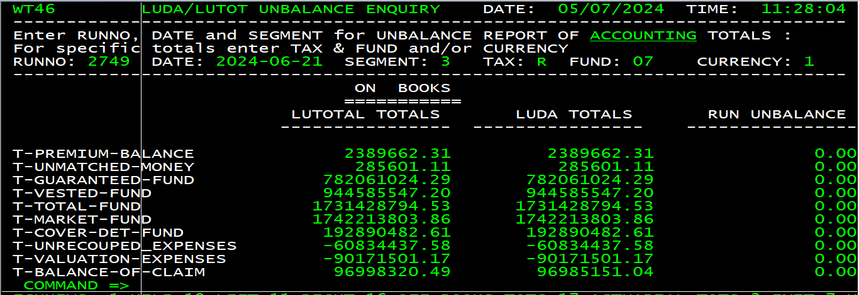
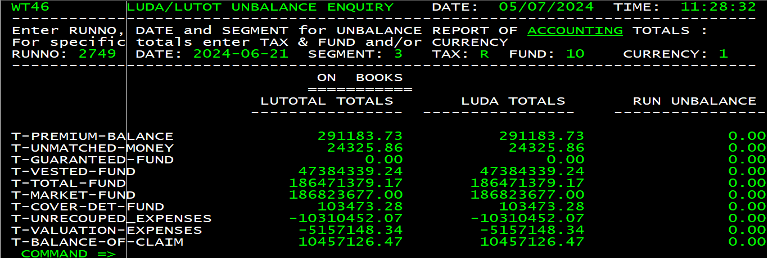
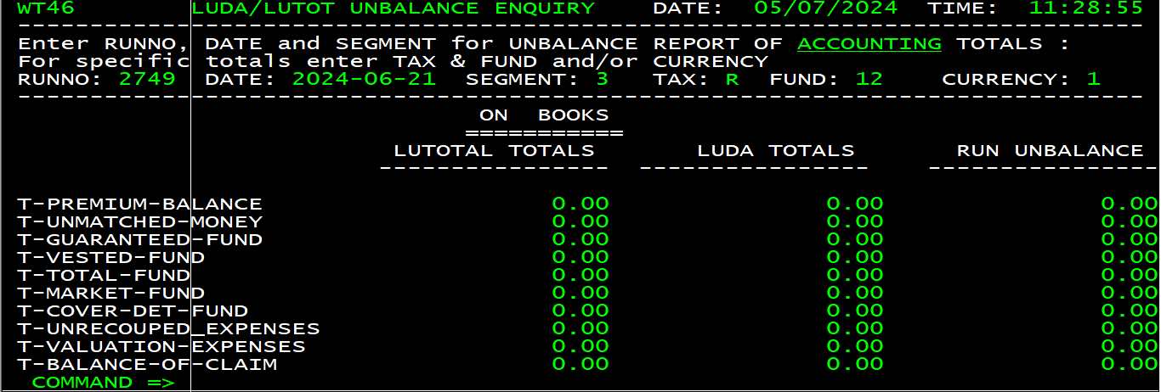
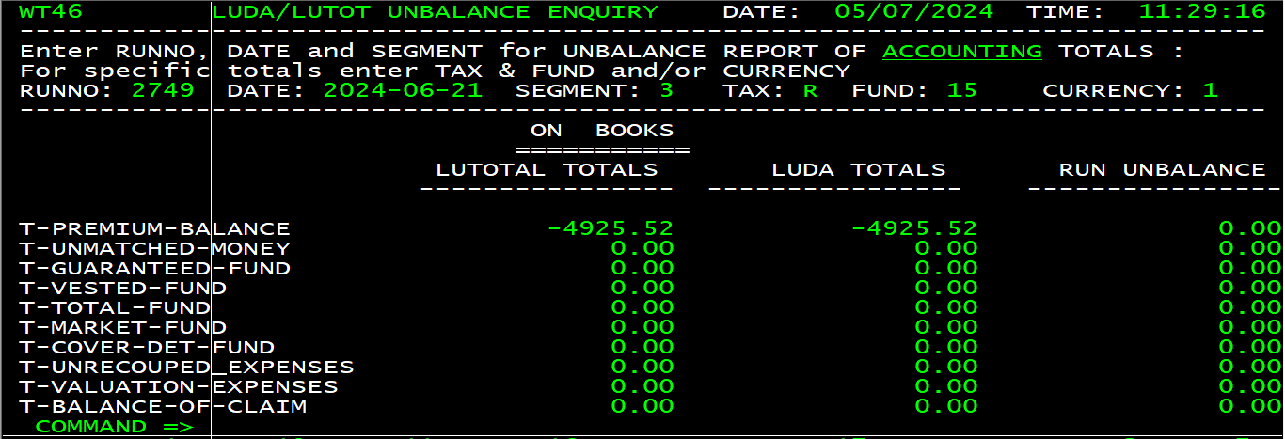
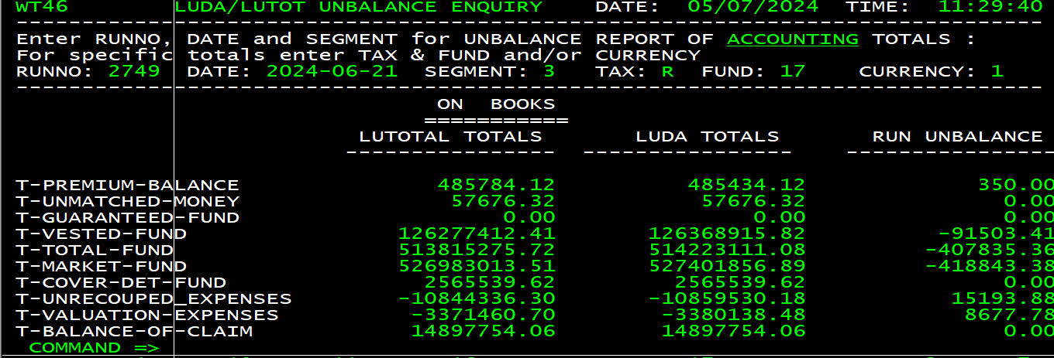
Now in the “RUN UNBALANCE” column we are seeing the same values which we have received from requestor.
Now with the help of this exercise we came to know in which week, Segment, tax, fund & currency this unbalance has happened and below is the information.
Week 17th to 21st June.
Segment 03.
Tax R.
Fund 17.
Currency 1.
Now according t the value of week we have to see is there any XLU or XWT batch job abended, if yes then we will first analyse those jobs
In our case we have seen two jobs ABCD#300 and ABCD#350 has been abended.
Now we will go into CA-VIEW and will try to see the log of the job. As it is segmented job and we know there is an unbalance into Segment 03, hence we will see only C (03) log of the job.
All segment jobs has been abended with JCL Error. Below is the screen shot for A segment job.
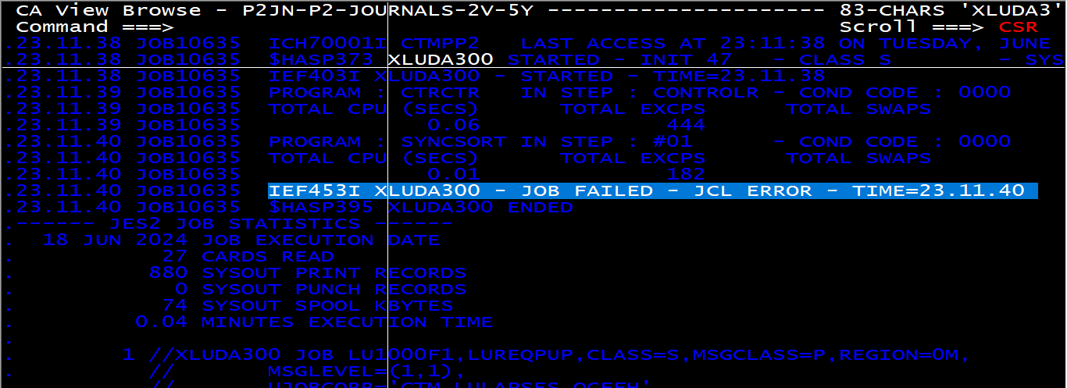
And the reason for the abend was.
It has happened because of the ASSEG,FHSEG & WRSEG reorg activity which has been performed over 15 to 16th June weekend and as a part of this activity they deleted these datasets so that spaces will get allocated automatically into IDMS for these systems.
So, the job has been rerun successfully after modification of the JCL/PROC. Below is the log from the successful run.

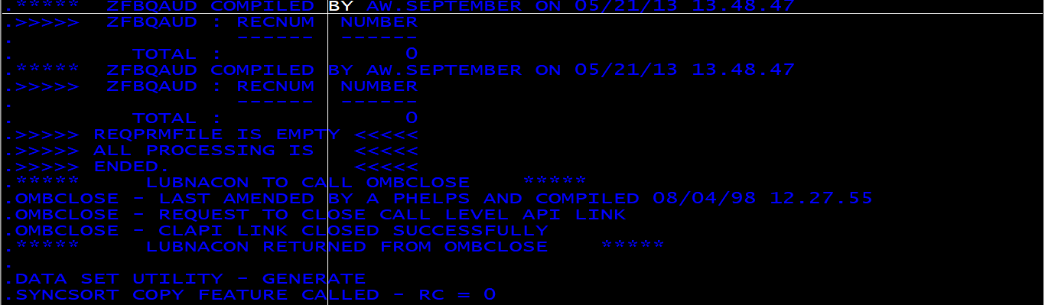
Now we will see log of the job ABCD#350, this job also has been abended with JCL error and to resolve the abend same action has been taken as mentioned above.

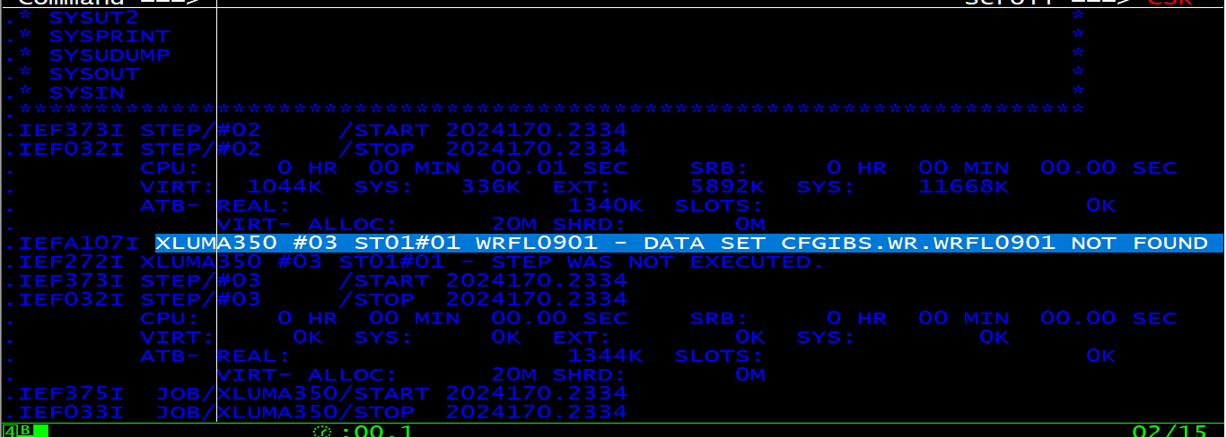
Second time when the job has been rerun it has been abended with 0966 and when we have tried running the job after sometime it went fine.
In this above two jobs we have not received any issues which can be unbalance, so now we have to start looking on the flexi job ABCD#102, which use to apply holding file and the input feed to the total job.
Now we have to see the input file CFGIBS.LU%%SEG.XXX.HFACCTOT of the job SHRXIBS.PROD.JOBEXEC as we know there is an issue into Segment 03 and also we know the date range into which we had an issue, hence we will look into the file of those dates only.
As this week was sort week so we have to see below three files only
CFGIBS.LU03.XXX.HFACCTOT.G7000V00
CFGIBS.LU03.XXX.HFACCTOT.G7001V00
CFGIBS.LU03.XXX.HFACCTOT.G7002V00
CFGIBS.LU03.XXX.HFACCTOT.G7003V00
Now we will be browsing these files into FILEAID one by one and will find policy number with combination where tax is R and fund 17.
Below is the screen shot for the same.
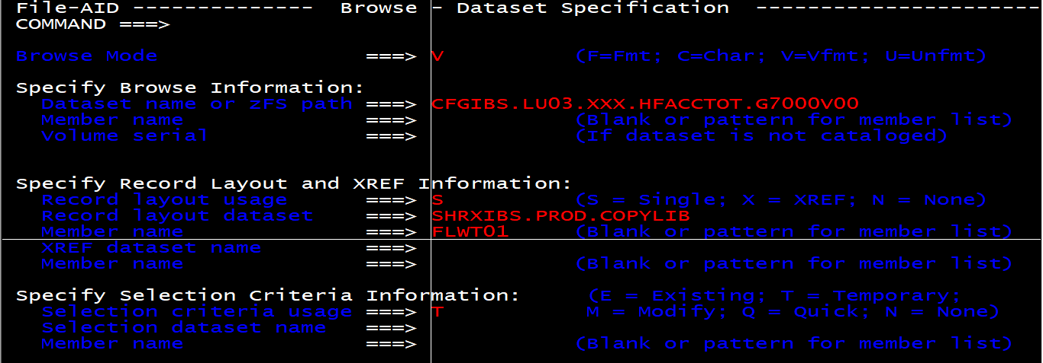
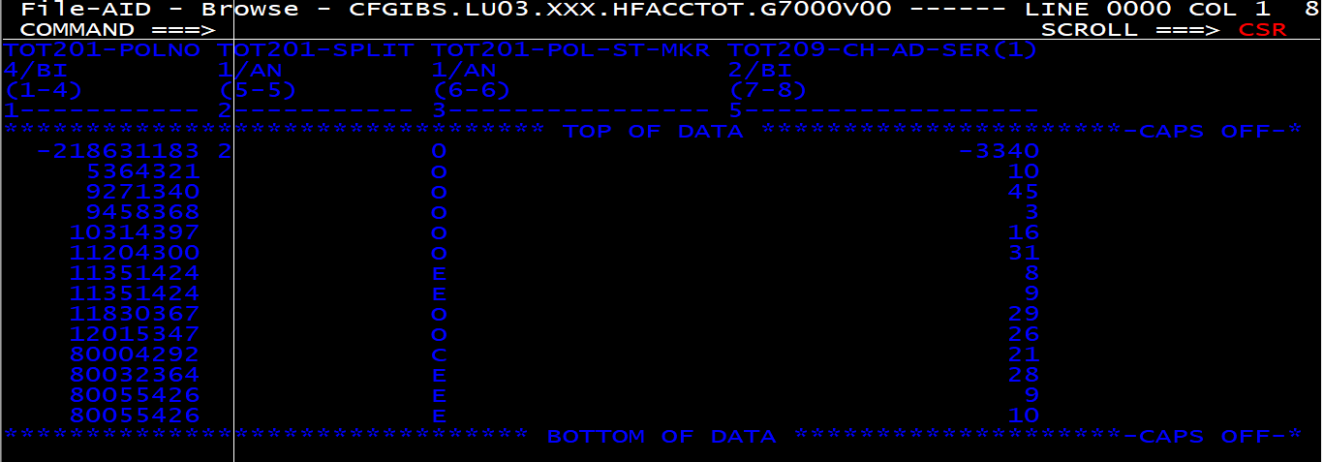
Now as we know tax and fund, now let’s apply filter and will get records only for those values.
For Fund variable name is TOT205-FUND-MKR
For Tax variable name is TOT205-TXD-MKR
Below is the screen shot for the same.
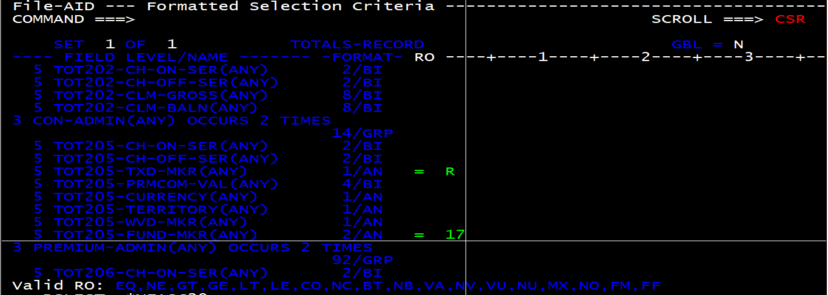
Once you will press PF3 button twice, you will see below screen which is providing you policy number and below is the screen shot for the same.
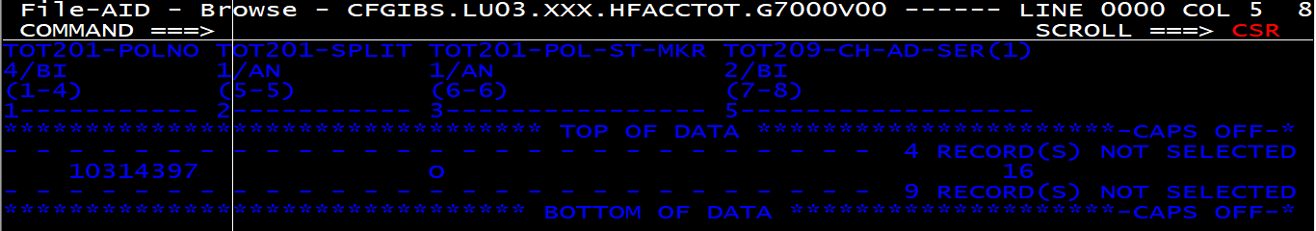
Now take this policy number and similarly look for all the policy with this combination and then pass those policy list to BA for analysis.
This time we got policy which is matching criteria.
In the above list if you will see policy 12092333 is coming twice and when I looked into the file, what we have seen the TOT202-CLM-GROSS & TOT202-CLM-BALN is matching with TOTAL-FUND unbalance amount and below is the screen shot for the same.
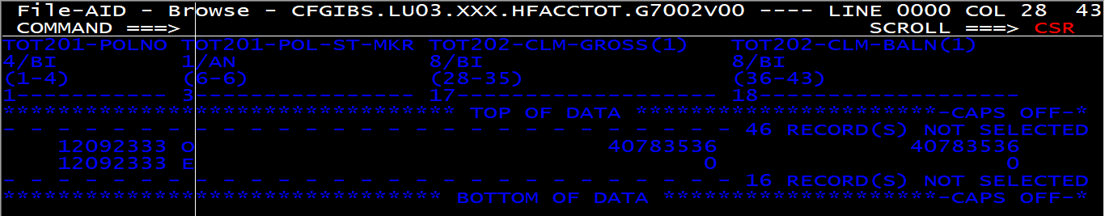

Scenario 1:- if we are unable to find policies for that unbalances for that day holding file then we need to follow below steps :
- Please check that particular week Holding files for the same with Run number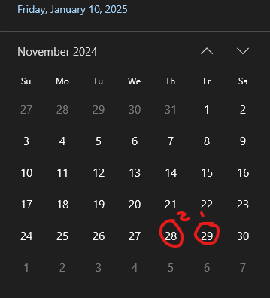
- If still didn’t find we need to start checking all the Totals file for that day with the segments number for e.g:-
CFGIBS.LU03.XXX.*TOT*
It will list all the totals file then we need to start looking one by one
Press ‘I’ in front of data sets check for modification data of file and look specifically for that file
If file is empty ignore it. If file is having only runno again ignore it . look for the files which are having policy numbers and check in file aid with formatted sections with TAX and FUND-MKR

Scenario :2:- Flexi Cashflows Dec 24 [CBA9716477]
Our observations for Dec 2024 unbalaces is in multiple segments and we got enquiry about only last week unbalance . But in that case we need to check all valid cycle one by one identify

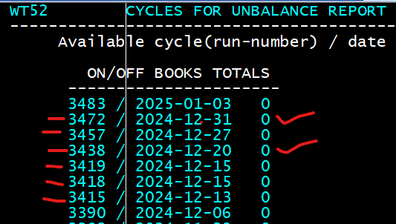
For our case we got unbalances in 2 Runno i.e:- 20th dec and 31st dec
In that case we need to start our investigation from 20th dec because some of totals values got incorrect entries
Hence we have started our investigations for 20-12-2024 with 3438 Run Number
Again, we need to check all the holding files for that day and check policy number if we didn’t find any policy we need to start checking all the Totals file for that day with the segments number for e.g:-
CFGIBS.LU03.XXX.*TOT*
It will list all the totals file then we need to start looking one by one
Press ‘I’ in front of data sets check for modification data of file and look specifically for that file
If file is empty ignore it. If file is having only runno again ignore it . look for the files which are having policy numbers and check in file aid with formatted sections with TAX and FUND-MKR
Observation/Finding for this scenario:-
We have investigated this and found that there was unbalance differences in 20th Dec, Cycle Number : 3438, SEG :03 , TAX :T , FUND :09 and total fund was R160943.83
For the Policy on the holding file I could see this is coming twice and when we looked into the file, we can see that TOT202-CLM-GROSS is matching close to around TOTAL-FUND unbalance amount R160943.83 and below is the screen print for the same.

Also , we can see this policy is auto matured and claim is pending as of 3rd Jan 2025.

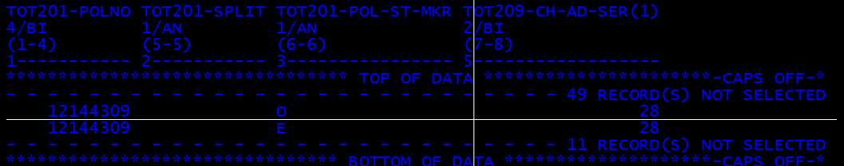

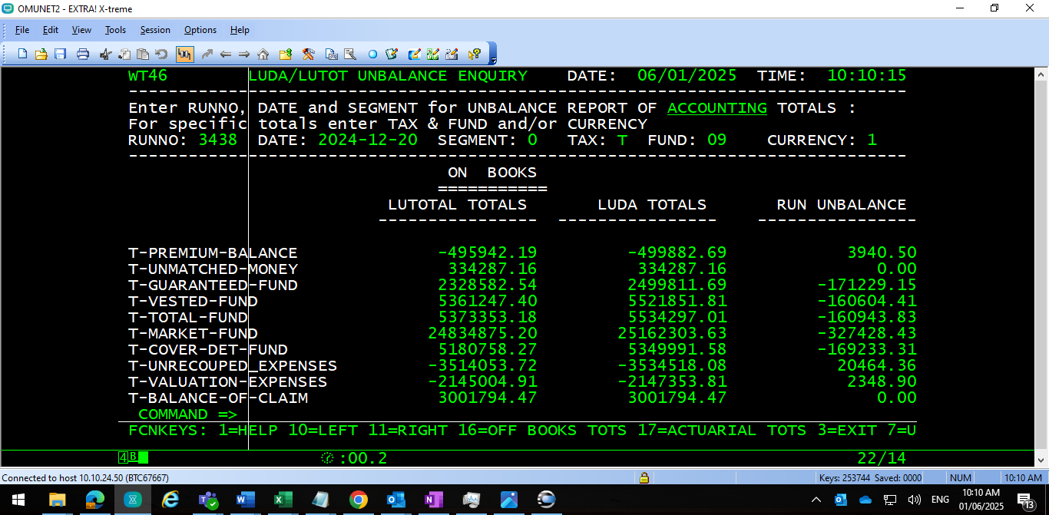

On 31st dec with Cycle number: 3471, SEG:05 ,TAX:R, Fund :07 -we could see only two policy which picked with TAX & Fund Mkr we might have cause -R1517 differences
And with SEG:07 ,TAX:R ,Fund :07- we found policy which picked with TAX & Fund Mkr and might have made R -5293 difference
If we sum up all the total unbalance difference of 31st Dec which is R-6810 and with 20th Dec file Total fund it will gives us R154133 which is exactly the same unbalance amount which we can see on month of Dec 24.

In short policy on 20th Dec holding file possibly could be the reason for differences.

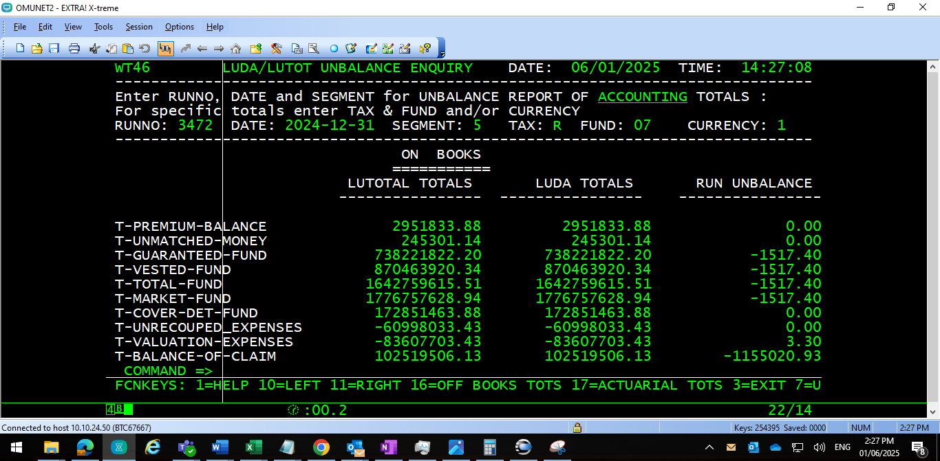

SEG:07 ,TAX:R ,Fund :07
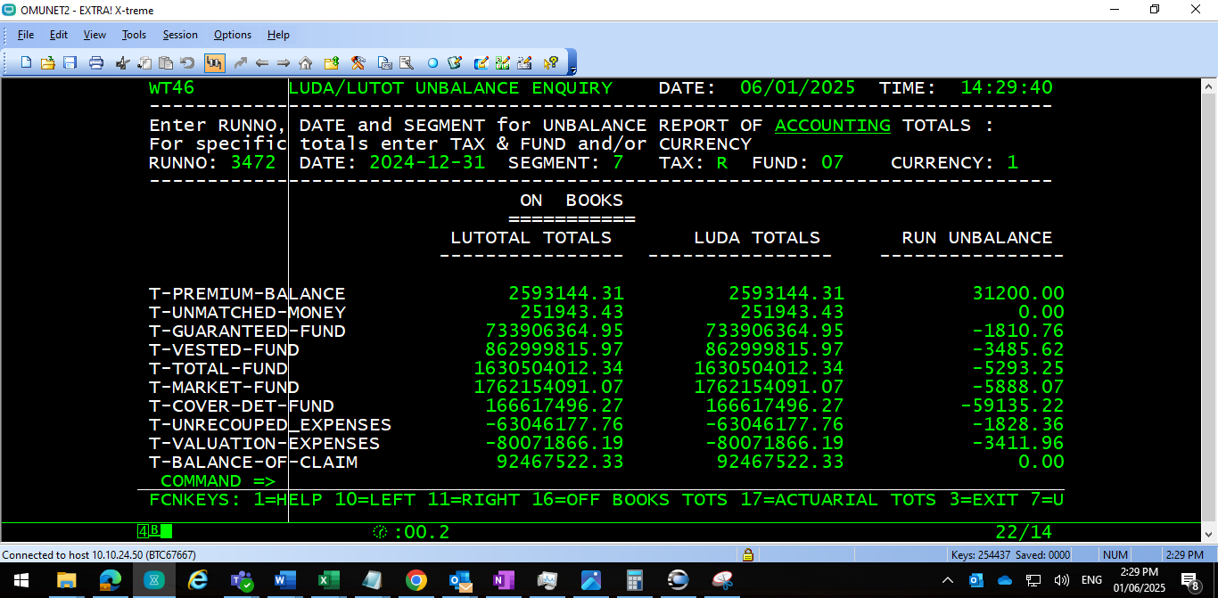

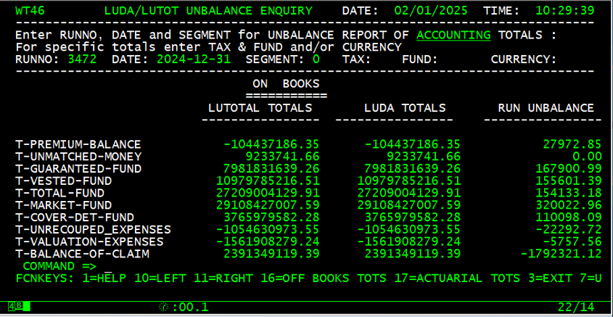

we have noticed above findings and which might be the reason for unbalance differences for Dec 24.

